LAB EXPERIMENT RECORD
Set 2: Customer Feedback Analysis
Department | AIML
Course Code / Course Name | DSA0601 / Data Handling and Visualization
Experiment | Data Visualization using R
Name | G. GANGA CHANDRIKA
Register Number | 1925260144
Date | 29 September 2026
Day | Tuesday

Aim
To visualize customer feedback data using a histogram, pie chart, stacked bar chart and word cloud in R, in order to understand the age distribution, satisfaction levels and prevalent customer statements.

Dataset: Customer Feedback
CustomerID | Age | Satisfaction | Age Group
1 | 25 | 4 | 20-29
2 | 30 | 5 | 30-39
3 | 35 | 3 | 30-39
4 | 28 | 4 | 20-29
5 | 40 | 5 | 40-49

PROGRAM 1: Histogram of Customer Ages
Create a histogram to represent the distribution of customer ages. Label the axes and title the chart.
customer <- data.frame(
CustomerID = c(1,2,3,4,5),
Age = c(25,30,35,28,40),
Satisfaction = c(4,5,3,4,5)
)

hist(
customer$Age,
main = "Distribution of Customer Ages",
xlab = "Age",
ylab = "Number of Customers",
col = "lightblue"
)
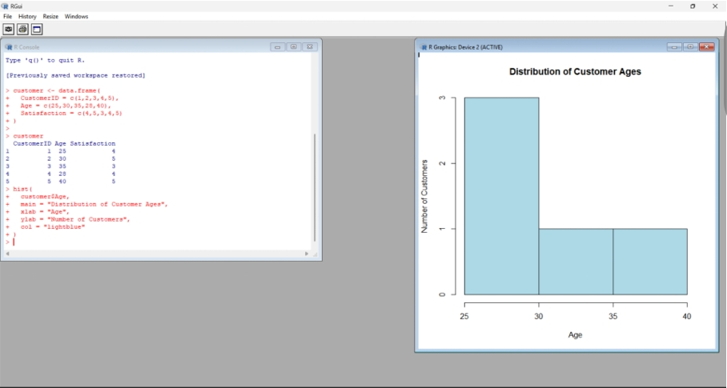
Output 1: Distribution of Customer Ages Histogram
Observation: Most customers fall in the 25–30 age range (3 customers), while the 30–35 and 35–40 ranges each contain 1 customer. The chart is title-labelled and both axes are labelled.

PROGRAM 2: Pie Chart of Satisfaction Scores
Generate a pie chart to display the overall distribution of customer satisfaction scores. Include labels.
satisfaction_count <- table(customer$Satisfaction)
satisfaction_count

pie(
satisfaction_count,
labels = paste0(
"Score ",
names(satisfaction_count),
" (",
round(100 * satisfaction_count / sum(satisfaction_count), 1),
"%)"
),
main = "Customer Satisfaction Distribution"
)
Console output: Score 3 = 1, Score 4 = 2, Score 5 = 2
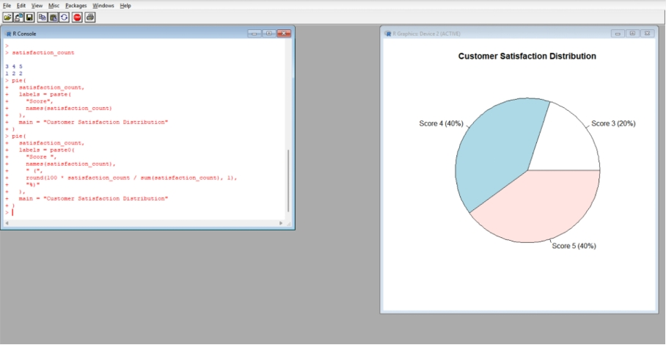
Output 2: Customer Satisfaction Scores Pie Chart
Observation: Scores 4 and 5 each account for 40% of the customers, and Score 3 accounts for 20%. Satisfaction is generally high, with no low scores.

PROGRAM 3: Stacked Bar Chart by Age Group
Build a stacked bar chart to visualize the distribution of customer satisfaction scores by age group.
customer$AgeGroup <- cut(
customer$Age,
breaks = c(19, 29, 39, 49),
labels = c("20-29", "30-39", "40-49")
)

age_satisfaction <- table(
customer$AgeGroup,
customer$Satisfaction
)
age_satisfaction

barplot(
age_satisfaction,
beside = FALSE,
main = "Customer Satisfaction by Age Group",
xlab = "Age Group",
ylab = "Number of Customers",
legend.text = TRUE
)
Console output:
3 4 5
20-29 0 2 0
30-39 1 0 1
40-49 0 0 1
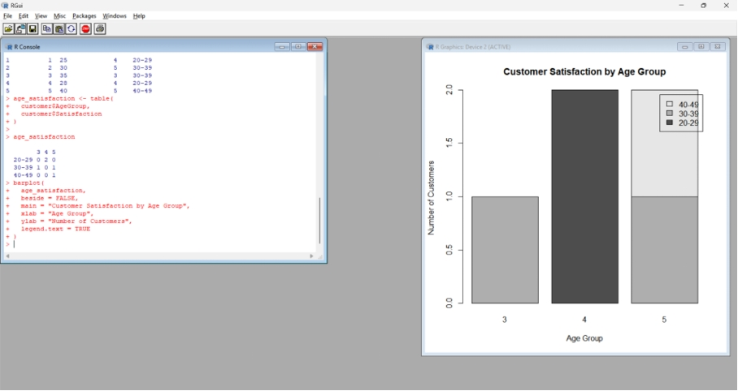
Output 3: Customer Satisfaction by Age Group (Stacked Bar Chart)
Observation: Each bar is a satisfaction score (3, 4, 5) and the stacked segments show the age groups (20-29, 30-39, 40-49). Score 4 comes entirely from the 20-29 group (2 customers). Score 5 is split between 30-39 and 40-49, and Score 3 comes only from the 30-39 group.

PROGRAM 4: Word Cloud of Customer Feedback
Develop a word cloud from open-ended customer feedback to identify prevalent customer statements.
library(wordcloud)
library(RColorBrewer)

feedback <- c(
"Good service and friendly staff",
"Excellent service and quick response",
"Service was average",
"Good quality and helpful staff",
"Excellent quality and fast service"
)

text <- paste(feedback, collapse = " ")
words <- unlist(strsplit(tolower(text), " "))

wordcloud(
words,
min.freq = 1,
random.order = FALSE,
colors = brewer.pal(8, "Dark2")
)
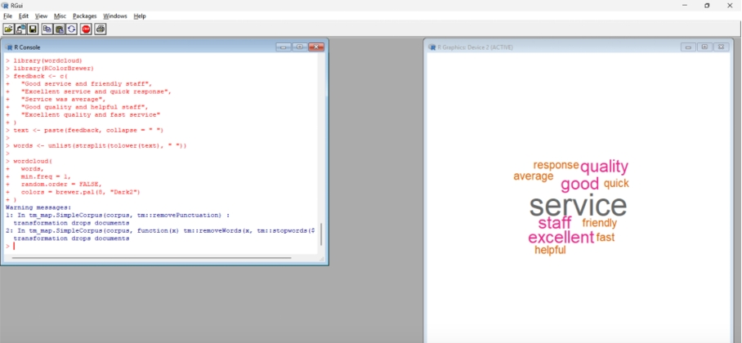
Output 4: Customer Feedback Word Cloud
Observation: "Service" appears most often (4 times) and is shown largest, followed by "excellent", "good", "quality" and "staff" (2 times each). Words such as "friendly", "quick", "fast", "helpful" and "response" appear once. Customers mainly talk about service quality and staff behaviour, in a positive tone. The two warnings shown are only text-mining notes and do not affect the output.

Procedure
1. Create a data frame with CustomerID, Age and Satisfaction, and use hist() to plot the age distribution with a title and axis labels.
2. Use table() to count the satisfaction scores and pie() with paste0() labels to show each score with its percentage.
3. Group ages into 20-29, 30-39 and 40-49 using cut(), build a cross-table of age group and satisfaction, and plot it with barplot(beside = FALSE) to get a stacked bar chart.
4. Prepare the open-ended feedback text, convert it to lowercase, split it into words, and use wordcloud() to visualize the frequent terms.

Result
The customer age distribution, satisfaction score distribution, satisfaction by age group and prevalent feedback terms were successfully visualized in R using a histogram, pie chart, stacked bar chart and word cloud.

